1. **INTRODUCTION**
   1. *overview*
      * *Description of the project*

Project Description:

Preparation and Maintanence of ZOHO Books for Dream Homes Realty Dream Homes Realty, a construction company, uses Zoho Books to track project expenses, manage subcontractor payments, and handle invoicing. They can generate estimates and invoices for clients, track job costing, and monitor the profitability of each project. Zoho Books provides them with financial insights to make informed decisions.

* 1. **PURPOSE**

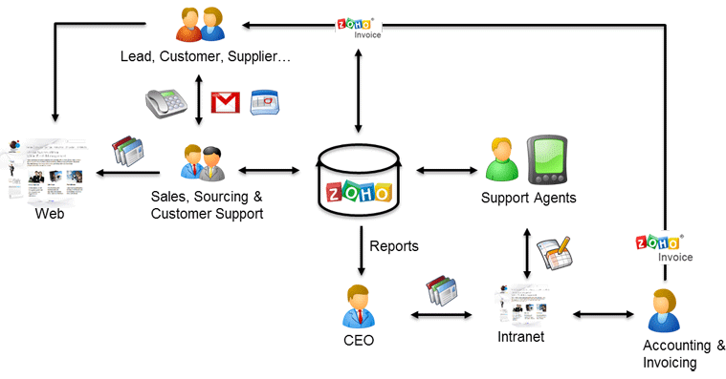

1. **Problem definition & design Thinking**
   1. *Empathy map*

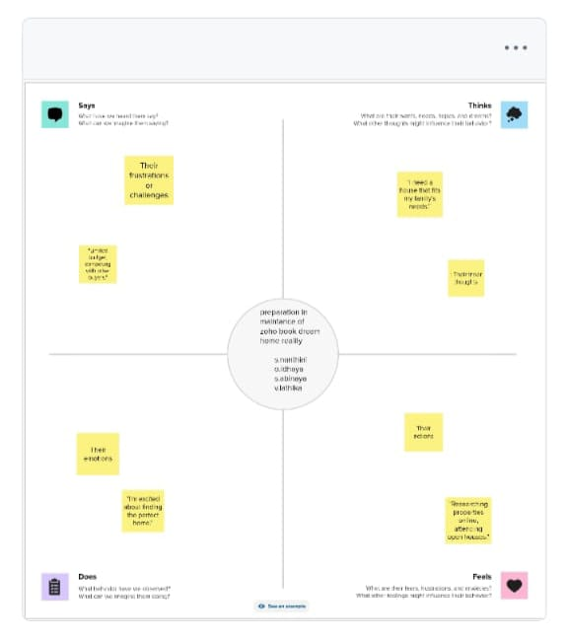

* 1. *Ideation & Brainstorming map*

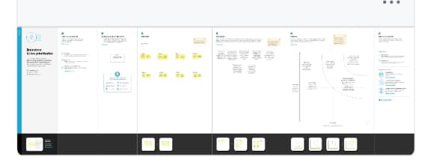

1. **Result Profit&loss**

**

Balance sheet:



Purchase order:

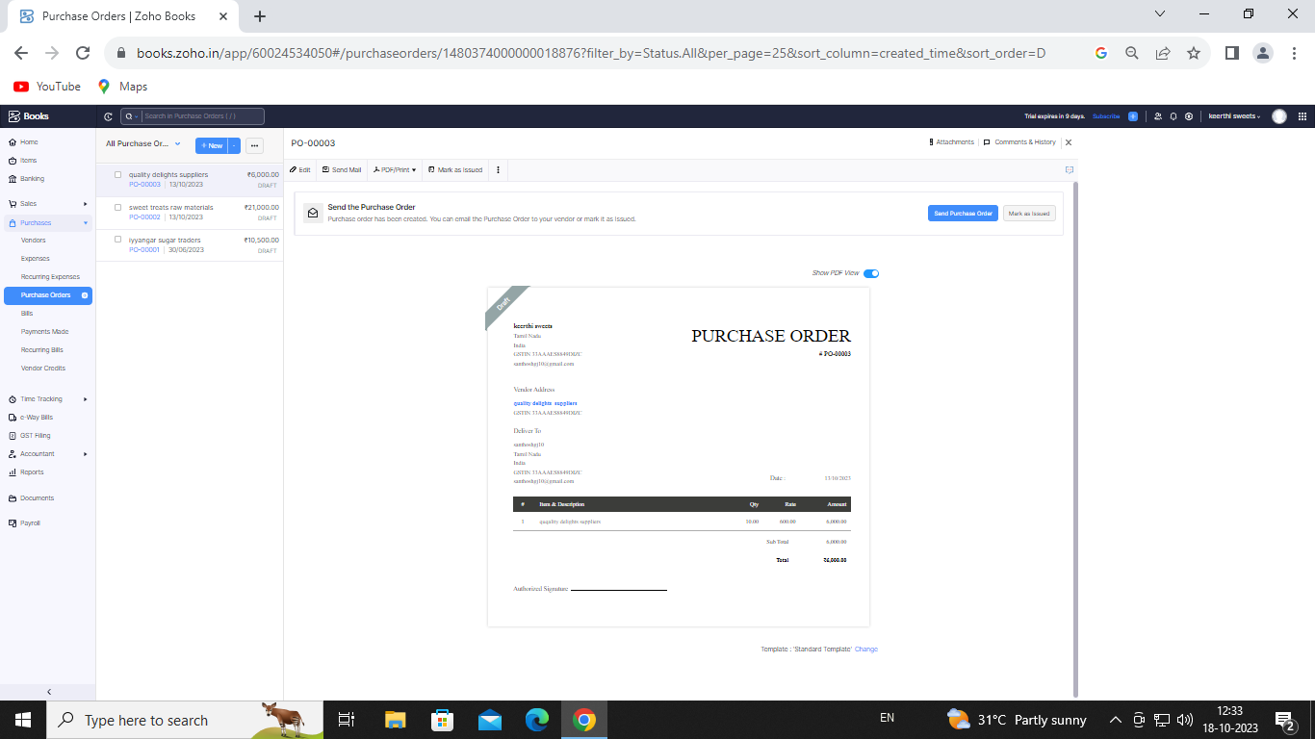

ADVANTAGES OF dream home:

Here are some of the advantages of building a dream home: Customization: Building your dream house

allows you to have complete control over the design and features of the home. You can tailor

every detail to your preferences and needs, creating a living space that suits your lifestyle perfectly.

DISADVANTAGES OF dream home:

The most widely recognized disadvantage to purchasing an existing home is that it is likely not going to be the exact dream you've envisioned. Since the home ...

*APPLICATIONS:*

dream home

1. **Conclusion:**

A house of my dream is composed of every beautiful thing that I have ever aspired for. A beautiful house is composed with sweet family members, clean and tidy environment, laughter and happiness all around every time. The following Short Essay on My Dream house is very expressive. This is quite helpful for children and students.

1. **FUTURE SCOPE:**

Open Living Plans. When looking for a home, many people tend to want open rooms and open concept living. .. Separate Pantry. ...Kitchen Island. ...Master Bedroom With Walk-In Closet and Bathroom. ...

Outdoor Entertainment. ...Natural Light. ...Two-Car Garage. ...Energy Efficiency.

1. **APPENDIX:**

<https://github.com/karthickraja2003/Drean-Homes-RealityNM2023TMID23216>

DOCTYPE html>

|  |
| --- |
| <html lang="en" data-color-mode="auto" data-light-theme="light" data-dark-theme="dark" data-a11y-animated-images="system" data-a11y-link-underlines="true"> |
|  |  |
|  | <style> |
|  | /* for each iteration, uncomment the CSS variable */ |
|  |  |
|  | /* light themes */ |
|  | [data-color-mode="light"][data-light-theme*="light"], |
|  | [data-color-mode="auto"][data-light-theme*="light"] { |
|  | /* iteration 1 */ |
|  | --border-color-iteration-1: #C8CCD0; |
|  | /* iteration 2 */ |
|  | --border-color-iteration-2: #BABFC5; |
|  | /* iteration 3 */ |
|  | --border-color-iteration-3: #A6ADB4; |
|  | /* iteration final */ |
|  | --border-color-iteration-4: #868F99; |
|  |  |
|  | /* the first value is the final step, which falls back to previous iterations */ |
|  | --control-borderColor-rest: var(--border-color-iteration-4, var(--border-color-iteration-3, var(--border-color-iteration-2, var(--border-color-iteration-1)))) !important; |
|  | } |
|  |  |
|  | /* dark themes */ |
|  | [data-color-mode="dark"][data-dark-theme*="dark"], |
|  | [data-color-mode="auto"][data-light-theme*="dark"] { |
|  | /* iteration 1 */ |
|  | --border-color-iteration-1: #363940; |
|  | /* iteration 2 */ |
|  | --border-color-iteration-2: #3F434B; |
|  | /* iteration 3 */ |
|  | --border-color-iteration-3: #4B5159; |
|  | /* iteration final */ |
|  | --border-color-iteration-4: #666E79; |
|  |  |
|  | /* the first value is the final step, which falls back to previous iterations */ |
|  | --control-borderColor-rest: var(--border-color-iteration-4, var(--border-color-iteration-3, var(--border-color-iteration-2, var(--border-color-iteration-1)))) !important; |
|  | } |
|  |  |
|  | [data-color-mode="dark"][data-dark-theme="dark_dimmed"], |
|  | [data-color-mode="dark"][data-dark-theme="light_high_contrast"], |
|  | [data-color-mode="dark"][data-dark-theme="dark_high_contrast"], |
|  | [data-color-mode="light"][data-light-theme="dark_dimmed"], |
|  | [data-color-mode="light"][data-light-theme="light_high_contrast"], |
|  | [data-color-mode="light"][data-light-theme="dark_high_contrast"] { |
|  | /* skip these themes, use the fallback */ |
|  | --control-borderColor-rest: initial !important; |
|  | } |
|  |  |
|  | @media (prefers-color-scheme: dark) { |
|  | /* dark colors in dark mode */ |
|  | [data-color-mode="auto"][data-dark-theme*="dark"] { |
|  | /* iteration 1 */ |
|  | --border-color-iteration-1: #363940; |
|  | /* iteration 2 */ |
|  | --border-color-iteration-2: #3F434B; |
|  | /* iteration 3 */ |
|  | --border-color-iteration-3: #4B5159; |
|  | /* iteration final */ |
|  | --border-color-iteration-4: #666E79; |
|  |  |
|  | /* the first value is the final step, which falls back to previous iterations */ |
|  | --control-borderColor-rest: var(--border-color-iteration-4, var(--border-color-iteration-3, var(--border-color-iteration-2, var(--border-color-iteration-1)))) !important; |
|  | } |
|  |  |
|  | /* light colors in dark mode */ |
|  | [data-color-mode="auto"][data-dark-theme*="light"] { |
|  | /* iteration 1 */ |
|  | --border-color-iteration-1: #C8CCD0; |
|  | /* iteration 2 */ |
|  | --border-color-iteration-2: #BABFC5; |
|  | /* iteration 3 */ |
|  | --border-color-iteration-3: #A6ADB4; |
|  | /* iteration final */ |
|  | --border-color-iteration-4: #868F99; |
|  |  |
|  | /* the first value is the final step, which falls back to previous iterations */ |
|  | --control-borderColor-rest: var(--border-color-iteration-4, var(--border-color-iteration-3, var(--border-color-iteration-2, var(--border-color-iteration-1)))) !important; |
|  | } |
|  |  |
|  | [data-color-mode="auto"][data-dark-theme="dark_dimmed"], |
|  | [data-color-mode="auto"][data-dark-theme="light_high_contrast"], |
|  | [data-color-mode="auto"][data-dark-theme="dark_high_contrast"] { |
|  | /* skip these themes, use the fallback */ |
|  | --control-borderColor-rest: initial !important; |
|  | } |
|  | } |
|  |  |
|  | @media (prefers-color-scheme: light) { |
|  | /* dark colors in light mode */ |
|  | [data-color-mode="auto"][data-light-theme*="dark"] { |
|  | /* iteration 1 */ |
|  | --border-color-iteration-1: #363940; |
|  | /* iteration 2 */ |
|  | --border-color-iteration-2: #3F434B; |
|  | /* iteration 3 */ |
|  | --border-color-iteration-3: #4B5159; |
|  | /* iteration final */ |
|  | --border-color-iteration-4: #666E79; |
|  |  |
|  | /* the first value is the final step, which falls back to previous iterations */ |
|  | --control-borderColor-rest: var(--border-color-iteration-4, var(--border-color-iteration-3, var(--border-color-iteration-2, var(--border-color-iteration-1)))) !important; |
|  | } |
|  |  |
|  | /* light colors in light mode */ |
|  | [data-color-mode="auto"][data-light-theme*="light"] { |
|  | /* iteration 1 */ |
|  | --border-color-iteration-1: #C8CCD0; |
|  | /* iteration 2 */ |
|  | --border-color-iteration-2: #BABFC5; |
|  | /* iteration 3 */ |
|  | --border-color-iteration-3: #A6ADB4; |
|  | /* iteration final */ |
|  | --border-color-iteration-4: #868F99; |
|  |  |
|  | /* the first value is the final step, which falls back to previous iterations */ |
|  | --control-borderColor-rest: var(--border-color-iteration-4, var(--border-color-iteration-3, var(--border-color-iteration-2, var(--border-color-iteration-1)))) !important; |
|  | } |
|  |  |
|  | [data-color-mode="auto"][data-light-theme="dark_dimmed"], |
|  | [data-color-mode="auto"][data-light-theme="light_high_contrast"], |
|  | [data-color-mode="auto"][data-light-theme="dark_high_contrast"] { |
|  | /* skip these themes, use the fallback */ |
|  | --control-borderColor-rest: initial !important; |
|  | } |